How to debug sonarlint

Once in a while sonarlint may crash on the analysis of a project. As sonarlint is embedded in sonar-csharp, you can’t use eclipse. The following guidelines expect that the sonarlint srashed with exitcode 1 similar to

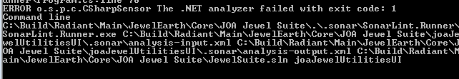

1. Check out the current version of sonarlint-vs. This can be found github.com/peterstevens130561/sonarlint-vs.
2. Open the solution in VisualStudio2015
3. Navigate to BHI.Runner
4. Open the Debug properties window
5. From the log, copy everything after SonarLint.Runner.exe in CommanLineArguments. Note that you must escape spaces in the paths, using “
6. Enter the working directory
7. Now you are ready to debug.